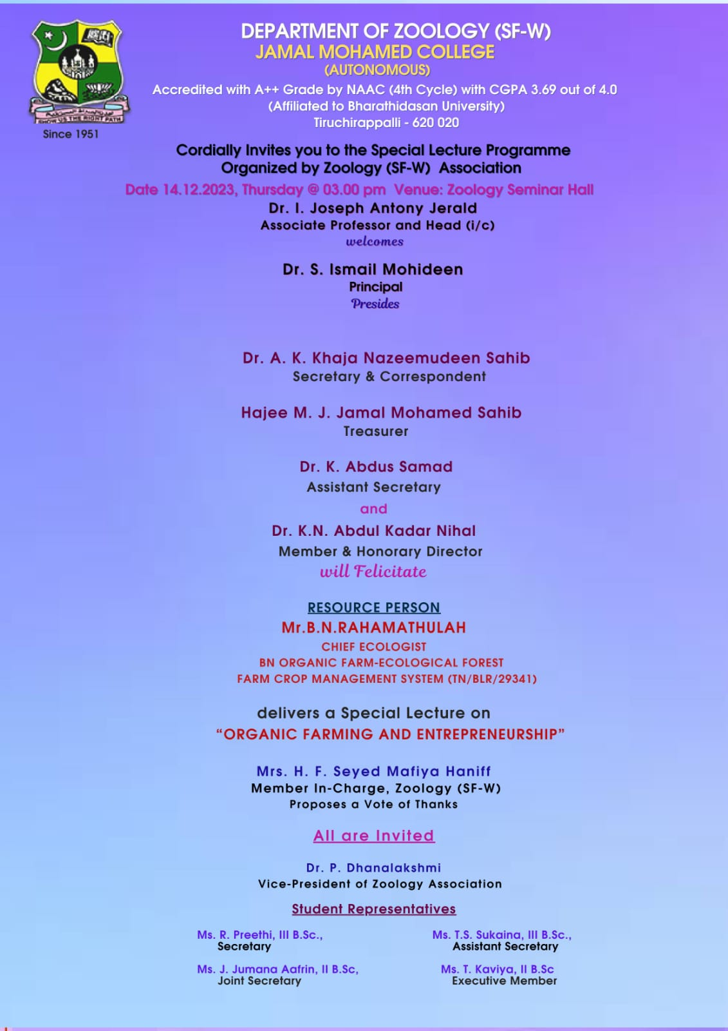

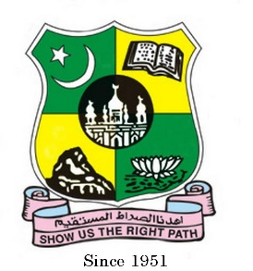
JAMAL MOHAMED COLLEGE (Autonomous)
Accredited (3rd Cycle) with ‘A’ Grade by NAAC
(Affiliated to Bharathidasan University)
TIRUCHIRAPPALLI – 620 020

REPORT

The Zoology (SF - Women) Association 2023 – 2024 special lecture was held on 14.12.2023, Thursday at 3:00 pm in Zoology Seminar Hall.

The Program started as the Chief Guest and other Dignitaries arrived at the college premises at 3.00 pm.The Master of ceremony was Ms. Annie Mercy of II BSc Zoology, Ms Harishma of III BSc Zoology and Ms. A. Jahanara Begum of I BSc Zoology.The occasion began with the faith of prayer by Ms. T. S.Sukaina of III BSc Zoology from the Holy Quran.

The students Kindled their love for the mother land by singing the Tamil Thai Valthu.To give a warm and pleasant welcome Mrs.Syed Mafiya Haniff Member Incharge of the department welcomed the gathering with her sweet words of welcome.

Dr. P. Dhanalakshmi Vice- President of Zoology Association welcomed the Chief Guest with the pleasure.

The honorable chief guest was Mr. Rahamathullah, Chief Ecologist, BN Organic Farm-Ecological Forest, Farm Crop Management System IND/BLR/29341 delivers special lecture on “Organic Farming and Entrepreneurship”.

The chief Guest gave an inspiring and innovative thoughts about the organic farm, their benefits and the measures to protect the environment. During his lecture , he asked many questions related to nature, organic manure and role of organic manure on the environment. Students as well as Staff members of Zoology department, was informative and enlightened by his wonderful lecture.

Mrs. H.F. Syed Mafiya Haniff , MID Zoology (SF-W) gave her gratitude towards the management and the chief guest to give the students an inspiring lecture. With the patriotism for the mother land the students sang the National Anthem. Our Guest graced us with their valuable words. The program marked it conclusion by 6:00 pm

